Chop n’ Drop on Blue Run

On a freezing day at the end of February, Trout Unlimited’s Coldwater Habitat Program and I ventured out into the frozen forest of the Blue Run Watershed. The goal of this venture was to improve water quality and fish habitat using a simple but interesting conservation tool - the “Chop and Drop”.
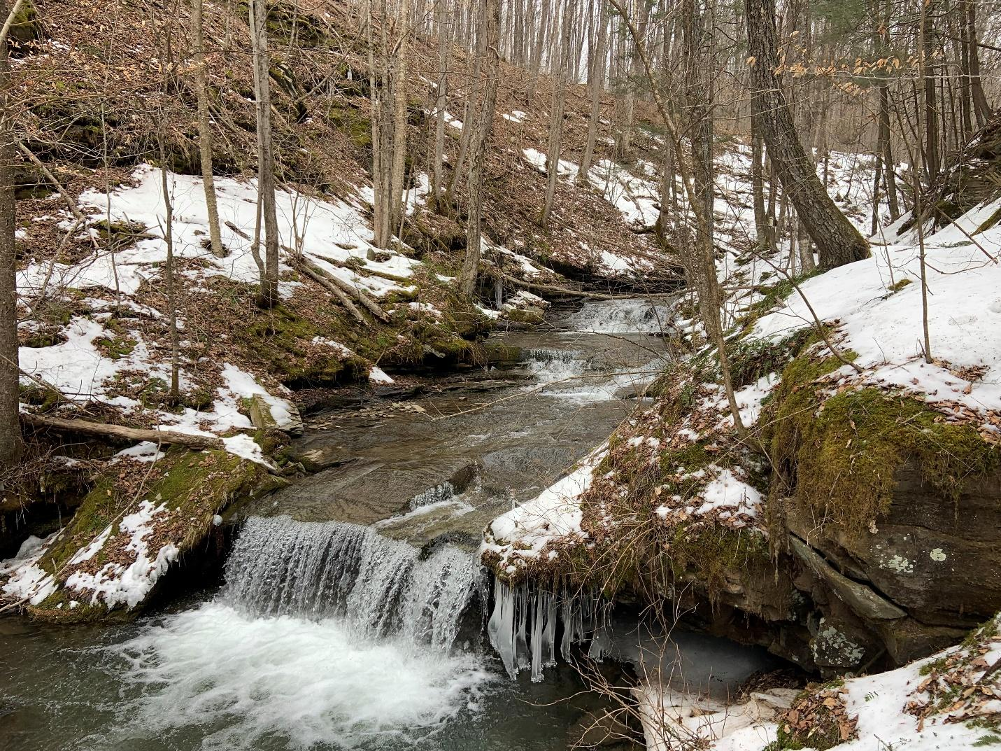
Blue Run is a beautiful tributary that leads into Long Run and is a favorite fishing destination for anglers. Part of Blue Run flows through private property owned by a logging company, but the top of the stream is encompassed by State Forest.

This stream was selected due to the Tiadaghton Chapter of Trout Unlimited’s initiative to improve the water quality of Long Run. Both Blue Run and Long Run are classified as a Natural Reproducing Trout Stream, but the chapter has its eye set on raising the classification of the stream to Class A to increase protections within the watershed.

The Chapter has been monitoring temperatures in the Long Run Watershed to determine if thermal impacts are inhibiting the trout’s growth. During this time, the Chapter worked with TU’s Cold Water Habitat Program to develop a snapshot survey. This survey located areas of concern in the watershed, and developed suggestions to fix these hot spots. Blue Run is one of the areas that was highlighted in that survey.

So, what is “Chop and Drop?” In short, the TU crew would cut trees and let them fall into the stream. This practice can also be known as “Directional Felling.” By strategically placing these trees, we are drastically increasing the habitat diversity. The tops of trees will aid in sediment capture and provide better spawning habitat for the fish found in the stream. By laying a log across the channel, it forces the stream to cut under it, building deeper pools. The increased wood in the stream will improve overhead cover and allow protection from predators. The addition of wood will also allow the stream to engage its floodplain, increasing the flood resiliency within the watershed.

In a previous blog post shared on this page, “A Wet Road is No Place for Wild Trout,” the author depicted finding a 23” brown trout while electrofishing. I had the privilege of being there as well, and we pulled the fish out of the most knotted up pile of wood in that stream. Wood in the stream is a necessary part of trout habitat.
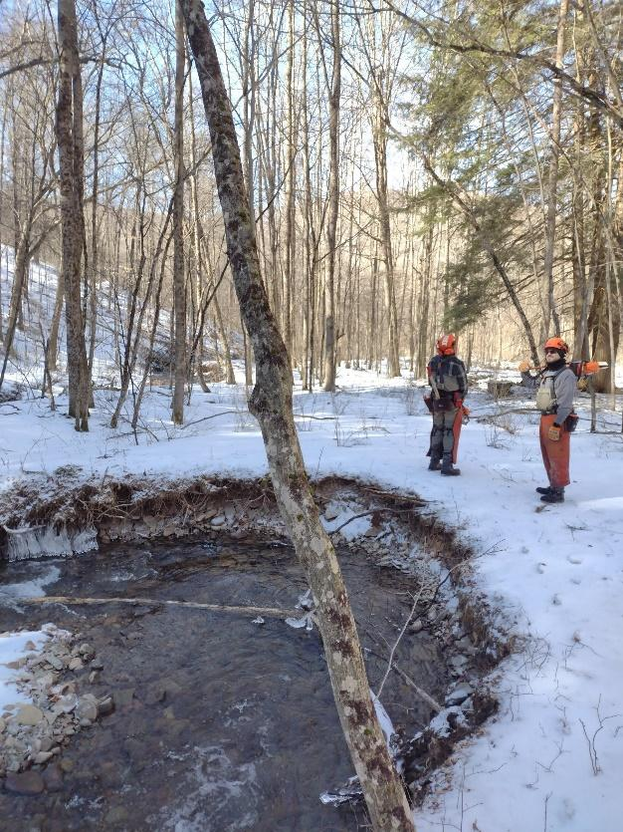
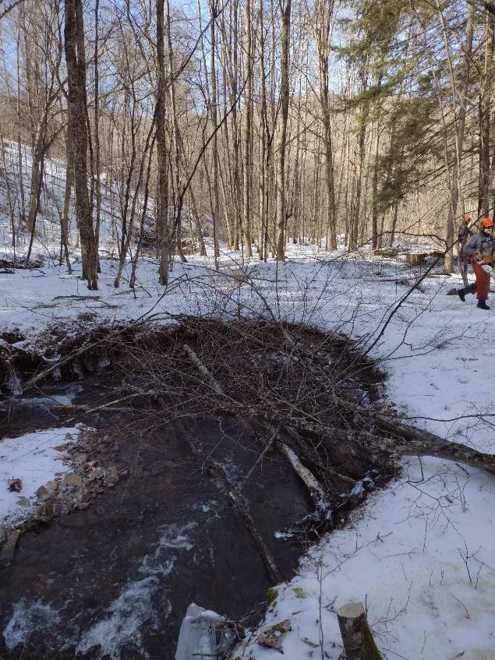

Each tree is woven together to provide stability and prevent them from washing downstream. Each “structure” averaged about four stems, but it always varied depending on what the structure’s goal was.

These structures are not strictly benefiting the stream, nor will the fallen trees only provide habitat for trout. To quote Phil Thomas, TU’s Coldwater Habitat Specialist, “We are building all sorts of habitat - wood turtle, rabbit. Heck! Even deer hunker alongside these fallen trees.” The influence of these structures landward was already evident as we spooked several deer on our walks upstream.

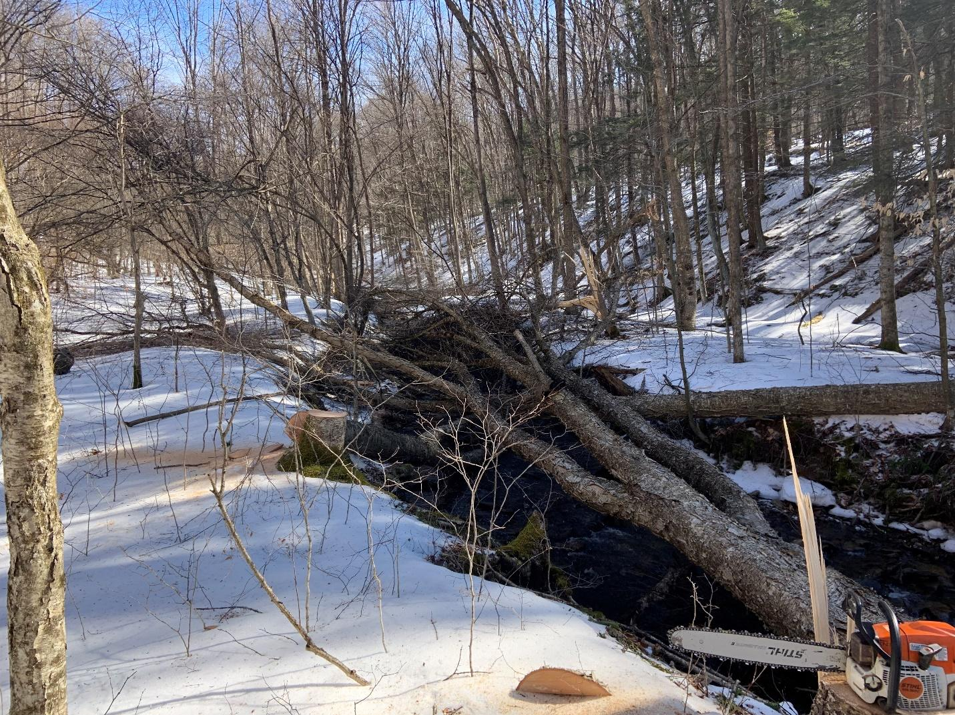
Phil, Scott Koser (Project Coordinator), and I were the ones implementing the project on Blue Run. Each morning, we would skate on top of the ice in the sub-freezing temperatures to our project locations, and every night, we would trudge through the snow and slush back to the trucks, exhausted from a long day’s work. We only carried the necessary equipment to get the job done. The TU crew looked like professional loggers with their chainsaws on their shoulders and wedges in their pockets. The furthest point we hiked in was about 1.6 miles up the watershed through very technical and slippery terrain.
Over the four days spent on Blue Run, there were 51 structures built over 1.6 miles of stream. This will drastically increase the diversity and habitat of the stream. These structures are predicted to prevent 1,473lbs of sediment from entering the stream annually.
This project would not have been completed without the help of various partners. The funds were provided by a grant through the Coldwater Heritage Partnership. The grant was held by the Tiadaghton Chapter of TU, but grant and project oversite was provided by me at the Tioga County Conservation District. The Coldwater Habitat Program of TU went above and beyond to build these structures and get this project done. Finally, Patterson Lumber Company and DCNR allowed us access and provided the trees for the entirety of the project.
Do I suggest this kind of project everywhere? No, but it works really well in circumstances like this. Blue Run is completely forested and has no roads or infrastructure in jeopardy of this project. The lack of roads also made it impossible to bring an excavator or any other heavy equipment along for construction.

In conclusion, Chop and Drop projects are a simple and cheap alternative for restoration. You can plan these kinds of projects in the most remote areas.

